ICS 4111: Embedded Systems & IoT
Practical Exercise 2: Circuit Design
Instructions:
For this exercise, you will largely use the EasyEDA software for circuit design. In part A, you can write the results of your calculations to a suitable document and export it as a PDF. For part B, export the designs directly from EasyEDA as PDF documents.

Part A
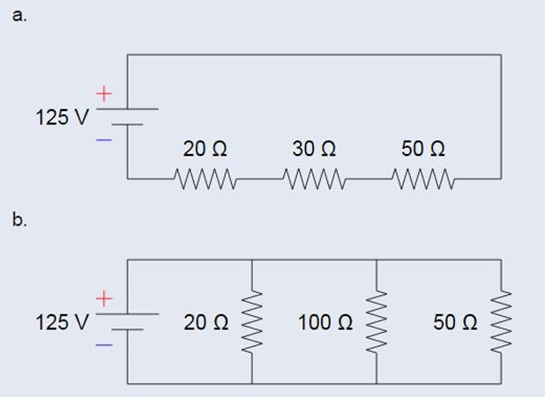

For each of these circuits:
- Calculate the total resistance in ohms,
A = 100Ohms
B = 12.5Ohms
- Calculate the total current from the power supply,
A = 1.25A
B = 10A
- Calculate the current through each resistor
A = 1.25A for all resistors
B = 20Ohms: 6.25, 100Ohms: 1.25, 50Ohms: 2.5
- Calculate the Voltage drop through each resistor
A = 20Ohms: 25V, 30Ohms: 37.5V, 50Ohms: 62.5V
B = 125V for all resistors
- Calculate the Power dissipated through each resistor (use Watt’s Law: Power = Voltage * Current)

A = 20Ohms: 31.25W, 30Ohms: 46.875W, 50Ohms: 78.125W
B = 20Ohms: 781.25W 100Ohms: 156.25W 50Ohms: 312.5W

Part B
- Develop schematic diagrams that describe the 2 circuits in Part A and include tables that list all components per schematic. See the example given here
- Design a schematic diagram for an Arduino Nano microcontroller connected to a DHT22 temperature and humidity sensor. For this schematic as well, develop a table that lists all the components. Find a reference schematic for the Arduino Nano here. (Note: DHT22 requires 3.3v-5v power supply)
Once done, publish your work to your GitHub account by following these steps:
  - Access your GitHub account and create a new repository: Circuit-Design
  - Upload all your documents to the repo.
  - After confirming the work is on your GitHub repo, copy the link to the repo from your address bar as github.com/AllanVikiru/Circuit-Design and submit this link on elearning before the due date. (confirm the appropriate due dates for your group on elearning).

Marking points for this work are correctness and completeness of the calculations and circuits.
Feel free to use any available resources for your work, however the rules against plagiarism apply. Do not directly use ChatGPT or any other AI content generators to develop your work, this will be penalised strictly when detected.

ICS 4111 [Apr-Jul 2026] Practical Exercise 2 || Page 2

